**How To: Enable Direct Line App Service Extension**

This guide describes how to enable the Direct Line App Service Extension using keys from your bot’s channel configuration and the Azure App Service resource where your bot is hosted.

***Gather your Direct Line Extension keys***

1. Open a web browser and go to <https://portal.azure.com/>
2. In the Azure Portal, locate your Azure Bot Service resource.
3. Click on “Channels” to configure the bot’s channels
4. If it is not already enabled, click on the Direct Line channel to enable it. If it is already enabled, in the Connect to channels table click on the “Edit” link on the Direct Line row.
5. Scroll down to the App Service Extension Keys section. Click on the Show link to reveal one of the keys, then copy its value.

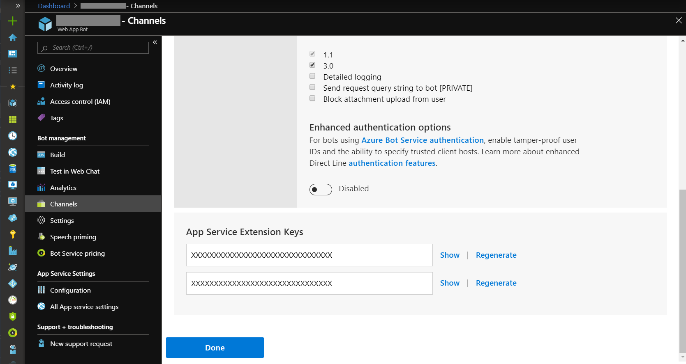

***Enable the Direct Line App Service Extension***

1. Open a web browser and go to <https://portal.azure.com/>
2. In the Azure Portal, locate the Azure App Service resource page for the Web App where your bot is or will be hosted.
3. Click on “Configuration”. Under the *Application settings* section, add two new application settings:

|  |  |
| --- | --- |
| Name | Value |
| DirectLineExtensionKey | <App_Service_Extension_Key_From_Section_1> |
| DIRECTLINE_EXTENSION_VERSION | latest |

1. Also within the “Configuration” section, click on the *General settings* section and turn “Web sockets” to On.
2. Click on “Save” to save the settings. This will restart the Azure App Service.
3. If you want to verify that it has started, navigate to https://<your_app_service>.azurewebsites.net/.bot and you should see JSON output similar to:

{"k":true,"ib":false,"ob":false,"initialized":true}